# **Mondofi Car Share Pre-Trip Info**

Last updated: Sep 12, 2022

**Previous step:** [**Mondofi Car Share Booking a Trip**](https://site.mondofi.com/mobile-app-content/car-share-user-guide/booking-a-trip/)

**Important**: On your mobile device, you must allow access for Mondofi to access your device ‘Location’.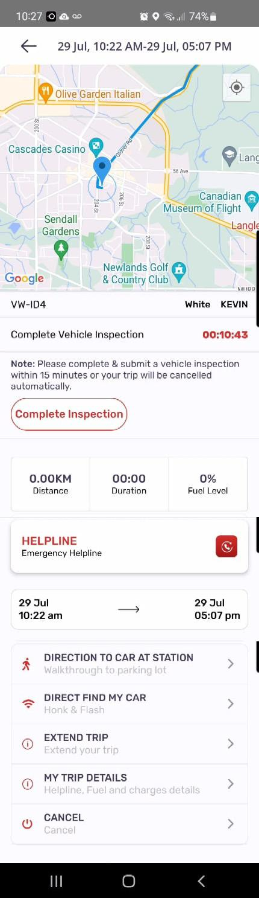

## Mondofi Mobile Application

All actions available to Members with the Mondofi Car Share program are accessed through the Mondofi Mobile Application.

On the Mondofi Mobile Application, on the MOCAR screen, you may create new bookings and view any of your upcoming bookings or your ongoing booking. Prior bookings, and their details, are also accessible by tapping the History tab.

## Locating the Vehicle

All Vehicles are located in the Designated Parking area of their corresponding Home Building.

You must have an ongoing or upcoming booking to locate your Vehicle.

On the **Mondofi Mobile Application**, on the **MOCAR** screen, under the **Trips** tab, tapping “**View**” will display your booking details, including an interactive **map** of your geographical region.

The **map** initially shows your device’s location as a **blue dot**. A blue continuous line may appear between your current location towards the Vehicle, which is indicated by a **blue pin**.

You must be near the vehicle in order to proceed.

## Rental Period Start

If your Booking was created with the “Schedule” option, then the Rental Period start time has been Scheduled at a future time. If this is the case, then your Rental Period will automatically begin at the specified time.

If your Booking was created with the “Book Now” option, your Rental Period will start immediately once you confirm your reservation.

## Pre-Trip Inspection

Once the Rental Period has started, you must complete a Pre-Trip Inspection within 15 minutes of the start time.

Failure to do so will result in cancellation of your booking, and a Cancellation Fee may be applied to your account as per the [Rate Schedule](https://site.mondofi.com/mobile-app-content/mobile-app-content-car-share-rate-schedule-parque-langley/).

To proceed with the Pre-Trip Inspection, tap the **Complete Inspection** button.

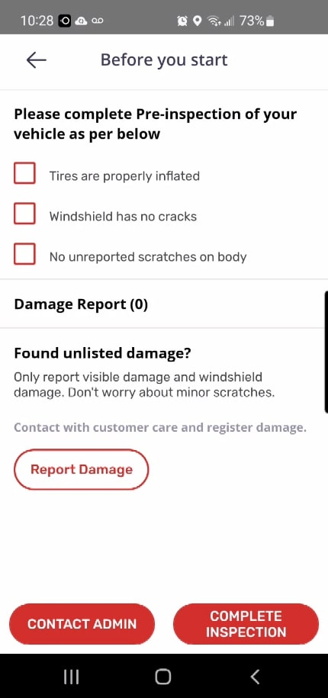

The Pre-Trip Inspection process includes the following:

1. A walk-around inspection of the Vehicle, inspecting the Vehicle for the following:

* Tires are properly inflated
* Windshield has no cracks
* No unreported scratches on body

Please tap each checkbox as each inspection point is completed.

1. A review of the existing **Damage Report** in the Mondofi Mobile Application, as reported by Members and ensuring any currently existing damage, dents or scratches to the Vehicle has been reported.

If any new damage, dents or scratches exist on the Vehicle that are not included in the Damage Report, you must report them by tapping the **Report Damage** button. Further instructions are available in the next section of this document.

**Important:** any unreported damage, dents or scratches may result in charges levied against you for the cost of required repairs, replacement parts, and any applicable Services Fees as outlined in the [Rate Schedule](https://site.mondofi.com/mobile-app-content/mobile-app-content-car-share-rate-schedule-parque-langley/).

Please make sure to report any new damage, dents or scratches via the **Mondofi Mobile Application** as indicated above or by contacting the **Mondofi Call Center** at **1-855-566-2272**.

Once you have completed the Pre-Trip Inspection, you may proceed by tapping the **Complete Inspection** button.

If you encounter any issues or have questions, tap the **Contact Admin** button at the bottom of the screen, to place a call from your device to the **Mondofi Call Center**. Alternatively, you may call the **Mondofi Call Center** at **1-855-566-2272**.

## Reporting New Damage, Dents or Scratches

If you notice any new damage, dents or scratches on the Vehicle during your Pre-Trip Inspection that are not already reported on the existing Damage Report in the Mondofi Mobile Application, then you must report the new damage, dents or scratches by tapping the **Report Damage** button and following the next steps,

Tapping the **Report Damage** button will display a form to complete by the Member. The form includes:

* Details description of the damage. Please include as much information as possible, including:
  + Location
  + Size
  + Severity
* (Optional) Image attachment. You can take a photo of the issue with the device directly from the Mondofi Mobile App. Once added, a thumbnail of the photo will be displayed in the attachment section. If you wish to delete a photo you have added, you may tap **delete** under the specific photo’s thumbnail.

Once the information has been entered, tap the **Add Damage** button to add your report to the Vehicle’s Damage Report. 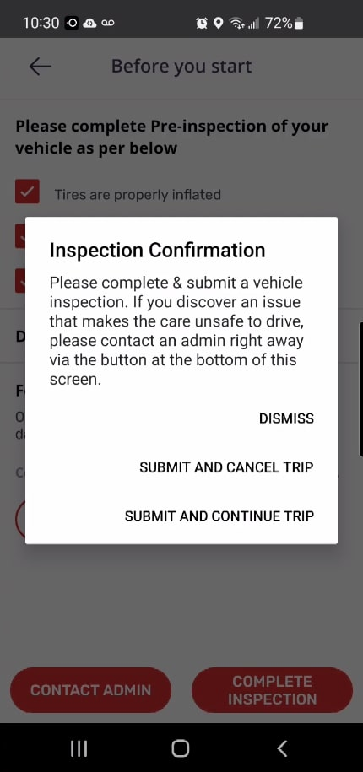

If you encounter any issues reporting any damage, dents or scratches, please contact the **Mondofi Call Center** at **1-855-566-2272**.

## Inspection Confirmation

Once you tap the **Complete Inspection** button, you will be asked to confirm whether you wish to proceed with your trip.

This step is to confirm that the Vehicle has been assessed as safe to operate.

To proceed with the trip, tap on **Submit and Continue Trip**.

To cancel your trip, tap on **Submit and Cancel Trip** and contact the **Mondofi Call Center** at **1-855-566-2272** right away.

**Important:** if you do not contact the Mondofi Call Center following this cancellation, you may be charged a Cancellation Fee according to the [Rate Schedule](https://site.mondofi.com/mobile-app-content/mobile-app-content-car-share-rate-schedule-parque-langley/).

## Proceeding with your Trip

Once the trip has started, you may unlock the Vehicle by tappingthe **Unlock Vehicle** button. Once the button is tapped, please wait a few seconds for the Vehicle to unlock. The Vehicle will provide visual and/or audible feedback in forms including:

* Headlights flashing,
* Noise from the door handles unlocking, and/or
* Mirrors opening

Once unlocked, you may proceed to open the Vehicle’s driver door and step inside the vehicle.

Please report any cleanliness or other issues by contacting the Mondofi Call Center either by tapping the **Helpline** button, or by calling **1-855-566-2272**.

The Vehicle Manual is located in the glove compartment, if needed.

Our vehicles do not require any keys or keyfobs to operate. Simply press the power button located near the steering wheel and proceed with your trip.

**Important:** please be mindful of the Rental Period end time. Late Return charges may be applied according to the [Rate Schedule](https://site.mondofi.com/mobile-app-content/mobile-app-content-car-share-rate-schedule-parque-langley/).

## Stopovers

If you make a stopover during your trip (a break in your trip before your End Time), your trip duration will continue to accumulate and charges will be applied accordingly.

Before leaving the vehicle unattended, please make sure to lock the vehicle by tapping the **Lock Vehicle** button on the App, and waiting to make sure the vehicle is locked. Additionally, please ensure that the windows are closed and the vehicle is turned off.

Once you are ready to continue your trip, you may unlock the vehicle by tapping the **Unlock Vehicle** button on the App.

**Reminder:** You may only end your trip once parked at the Home Building.

## Extending your Trip

Depending on the Vehicle’s availability, you may have the option to extend your trip.

Tapping the **Extend Trip** button on the Mondofi Mobile Application will display a form which prompts you to enter a new return time.

Enter the new date and time desired and then tap **Done**.

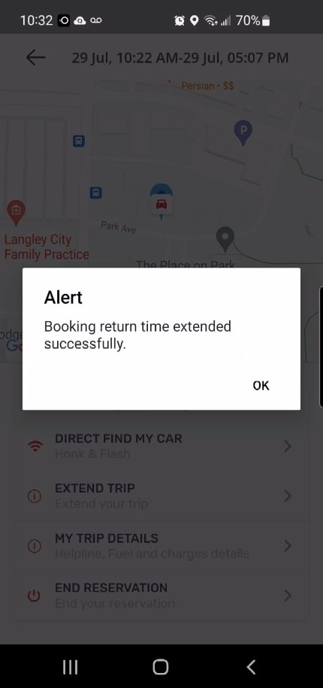

### *Trip Extended Successfully*

If the Vehicle is available during the new desired Rental Period, you will be notified via the App that your trip has been extended.

If the Vehicle is not available during the extension period, then another member has booked the Vehicle during this period and your trip must be ended before the specified End Time.

**Next steps:**

* [**Mondofi Car Share Post-Trip Info**](https://site.mondofi.com/mobile-app-content/mobile-app-content-car-share-post-trip-info/)
* [**Mondofi Car Share Trip History**](https://site.mondofi.com/mobile-app-content/car-share-user-guide/trip-history/)

## Related Documents

* [Glossary of Terms](https://site.mondofi.com/mobile-app-content/mobile-app-content-car-share-glossary/)
* [Terms & Conditions](https://site.mondofi.com/mobile-app-content/mobile-app-content-car-share-terms-conditions/)
* [Privacy Policy](https://site.mondofi.com/mobile-app-content/mobile-app-content-privacy/)
* [FAQ](https://site.mondofi.com/mobile-app-content/mobile-app-content-car-share-faq/)
* [Rate Schedule](https://site.mondofi.com/mobile-app-content/mobile-app-content-car-share-rate-schedule-parque-langley/)
* [Pre-Trip Info](https://site.mondofi.com/mobile-app-content/mobile-app-content-car-share-pre-trip-info/)
* [Post-Trip Info](https://site.mondofi.com/mobile-app-content/mobile-app-content-car-share-post-trip-info/)
* [Insurance Info](https://site.mondofi.com/mobile-app-content/mobile-app-content-car-share-insurance-info/)
* [User Guide](https://site.mondofi.com/mobile-app-content/car-share-user-guide/)